**DAILY ONLINE ACTIVITIES SUMMARY**

|  |  |  |  |  |  |  |  |
| --- | --- | --- | --- | --- | --- | --- | --- |
| **Date:** | **17-06-2020** | | | | **Name:** | **B.A.SOHANKUMAR** | |
| **Sem & Sec** | **4TH SEM A** | | | | **USN:** | **4AL18CS013** | |
| **Online Test Summary** | | | | | | | |
| **Subject** | | **----** | | | | | |
| **Max. Marks** | | **----** | | **Score** | | **----** | |
| **Certification Course Summary** | | | | | | | |
| **Course** | **MACHINE LEARNING FOUNDATIONS** | | | | | | |
| **Certificate Provider** | | | **GLA** | **Duration** | | | **6 HOURS** |
| **Coding Challenges** | | | | | | | |
| **Problem Statement :Write a c program to count numbers that don’t contains 3.** | | | | | | | |
| **Status: EXECUTED** | | | | | | | |
| **Uploaded the report in Github** | | | | **YES** | | | |
| **If yes Repository name** | | | | **LOCKDOWN CODING** | | | |
| **Uploaded the report in slack** | | | | **YES** | | | |

**ONLINE CERTIFICATION DETAILS:**

Course: Machine learning foundations

Completed topics are Intro to Artificial Intelligence and Machine Learning,Machine learning 101,Machine Learning Contd,Linear Regression Part - 1,Linear Regression Part-2,Multivariate Linear Regression,Categorical Independent variables in Regression,Root Mean Square Error and Mean Absolute Error,Linear Regression - Pro & Cons,Hands On Linear Regression,Hands on Linear Regression.ipynb,auto-mpg.csv,Introduction to Machine Learning.

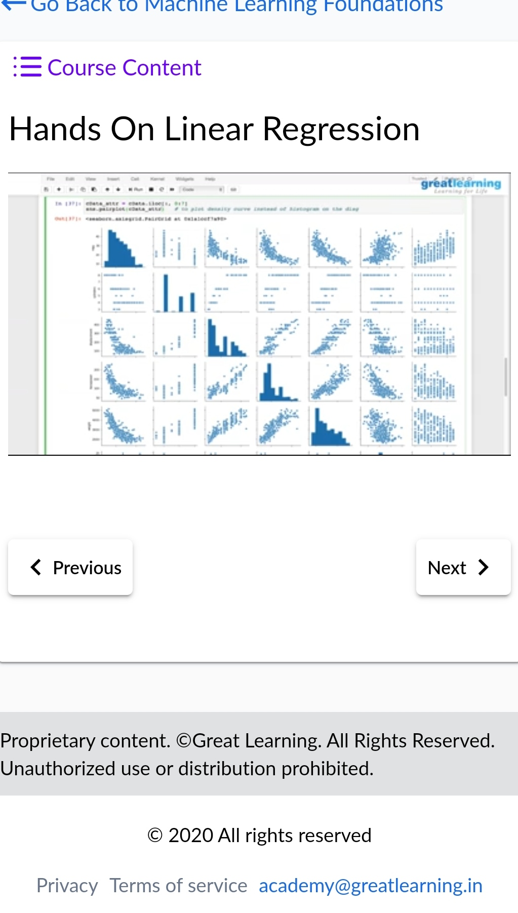 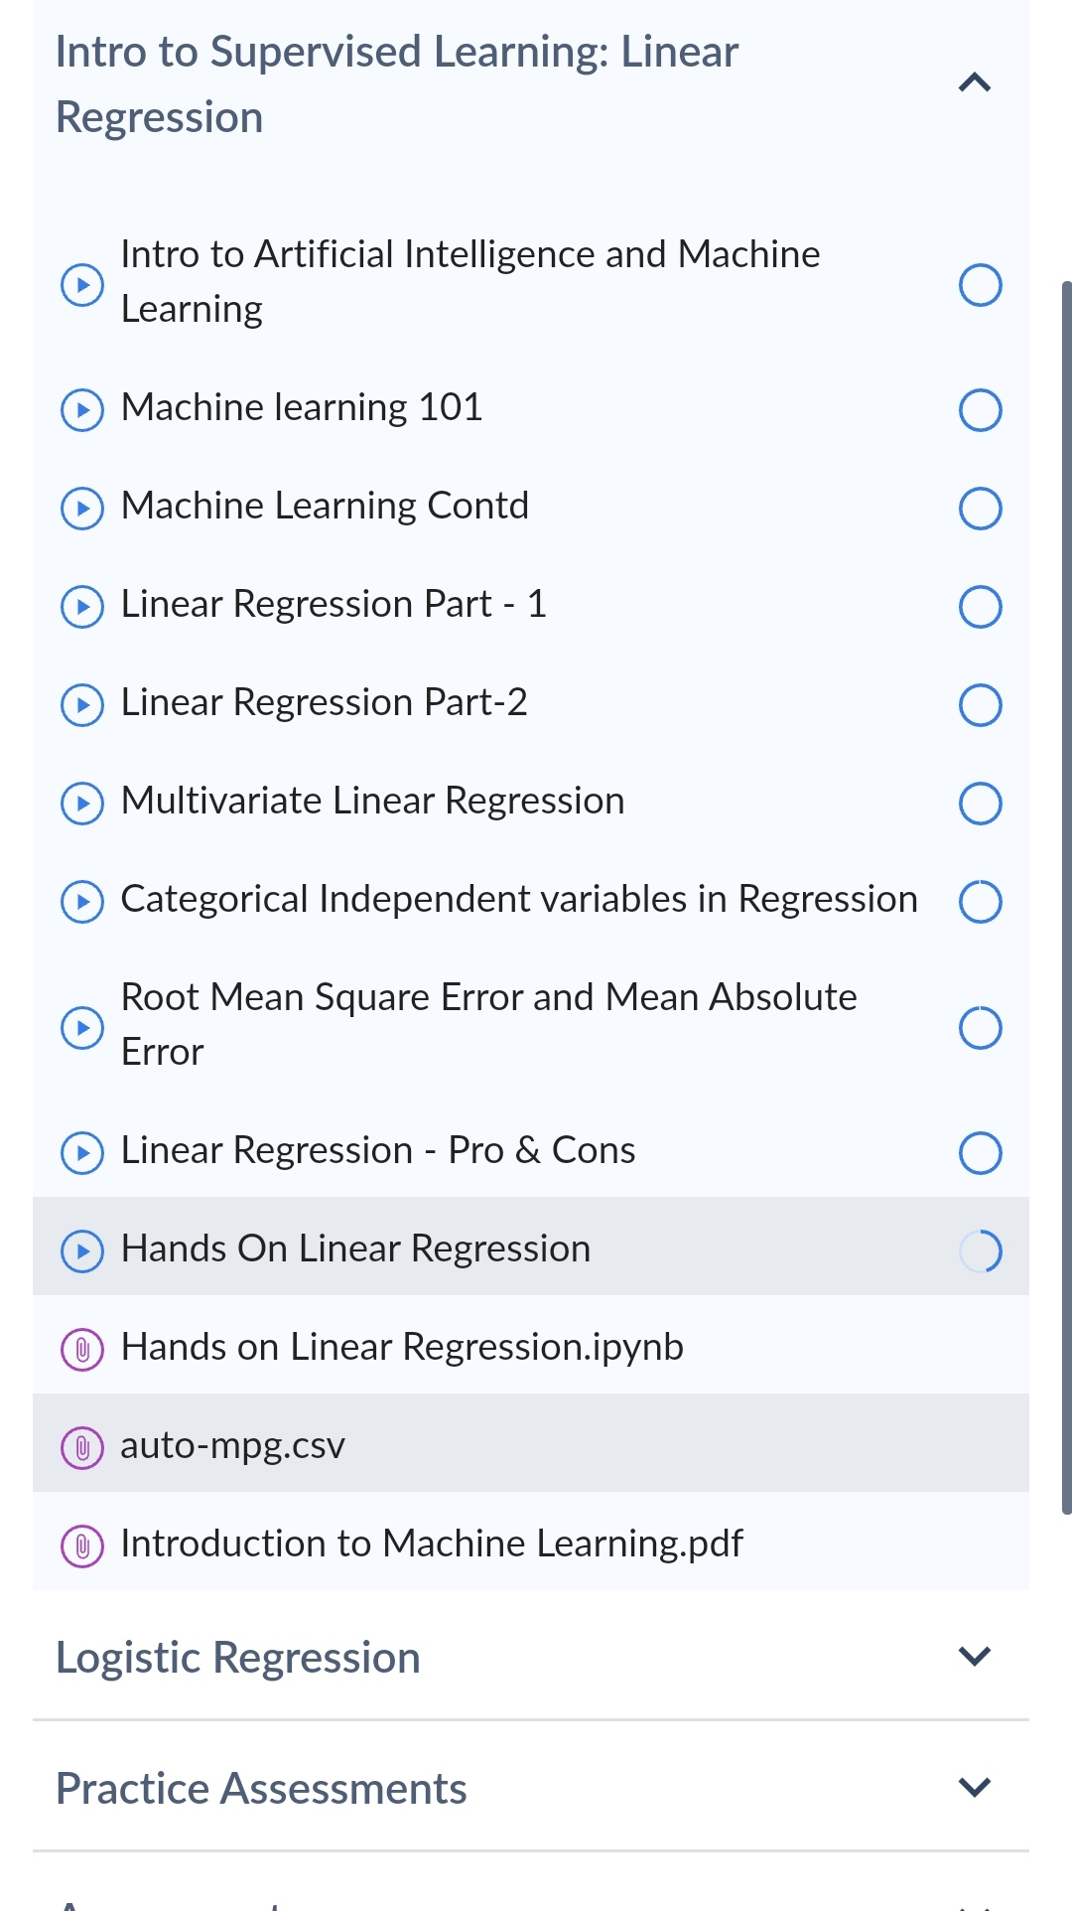

**CODING CHALLENGES DETAILS:**

1.Write a c program to count numbers that don't contain 3.Given a number n, write a function that returns count of numbers from 1 to n that don’t contain digit 3 in their decimal representation.

Example:-> Input: n = 10 Output: 9

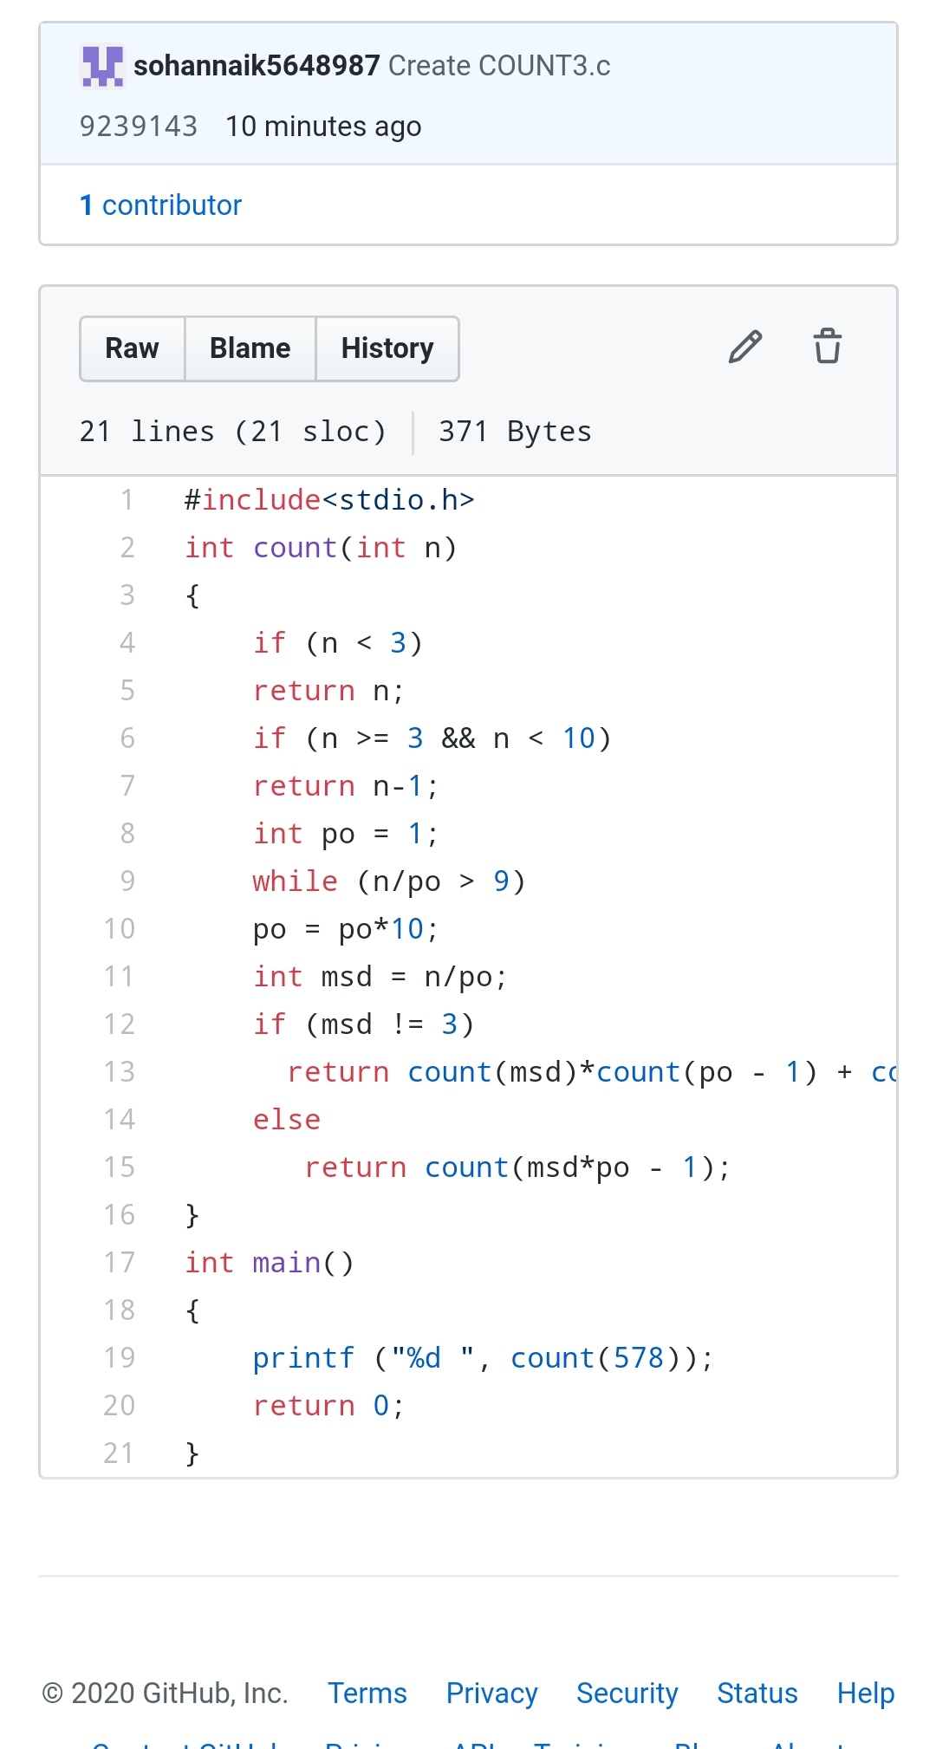

REPOSITORY LINK:https://github.com/sohannaik5648987/C-CODING